**MKOREAN SV 7 2025 BOT STRATEGY**

**SV** **7** **BOT** is an AI bot working best on Over Under Market and some bit of Matches. The bot only function **mkoreanwwn.com site** available on GOOGLE CHROME. It doesn’t in a DERIV so that it can reduce the habit of selling this free bot.

**Features of SV 7 bot**

1. It has two prediction sites.
2. It has block for inserting your entry point.
3. It has a stop loss and take profit working efficiently.
4. It’s fast and accurate.

**What to consider in SV 7**

Avoid Green bar at digit 8 or Digit 9 to avoid pulling to moving cursor to digit above 7 that is 7, 8 and 9 .

**How does MKOREAN SV 7 bot works**

**Strategy for Beginners in SV 7**

**Set bot to this settings**

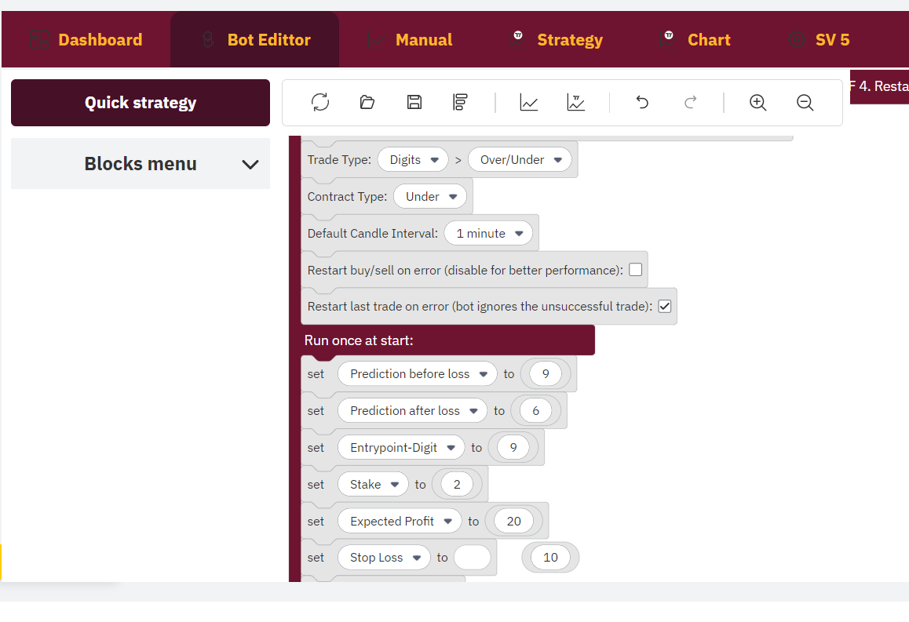

**After setting (it’s means)**

You’re trading **UNDER 9**

Then after loss it will it trade **UNDER 6**

After a loss it add 0.01 USD to your stake then after two wins it returns to your normal stake.

Incase of two consecutive losses, there will be a martingale to recover your losses.

**Strategy for SV 7 bot for a Deriv pro**

Set your bot to this settings

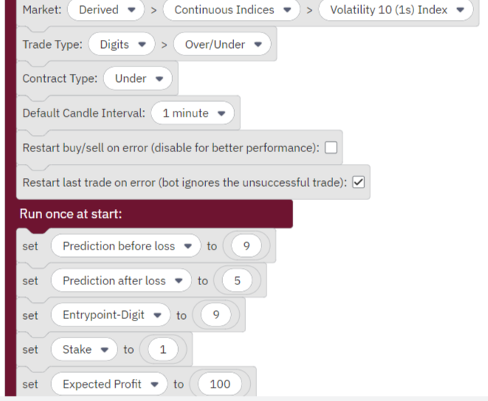

**After setting (it’s means)**

You’re trading **UNDER 9**

Then after loss it will it trade **UNDER 5**

After a loss it add 0.01 USD to your stake then after two wins it returns to your normal stake.

In case of two consecutive loss, there will be a martingale to recover your losses.

**Requirements for Deriv pro’s**

Make sure green bar at digits less than 5 and your entry point be obviously digit 9.

THE END

It’s **always Mnyamaa** incase of anything just contact me via WhatsApp **0727** **835** **080 only**